

**Ralazaba Electronics**

PROJECT AMR

Critical Design Review Report

**A device trying to extract the plan of their surroundings**

Prepared for

Assoc. Prof. Lale ALATAN

**Project Start Date:** 30.10.2018 **Project Completion Date**: 18.05.2019

**Project Duration:** 7 Months

**Introduction**

In this project, the main objective is to design an autonomous robot which plans a bounded environment containing an unknown number of objects by telling the number of objects, their shapes, sizes, and centers, produce a map and send it to the monitor. Moreover, the robot should finish this planning operation in the shortest time, and minimum error as possible. Main features of the robot are:

* To move in x y directions a bounded environment by visiting all regions of the environment
* To make self-localization for detecting the current position of the robot in real time
* To sense objects and bounds of the environment
* To get all necessary data from the objects and environment and combine these data and transfer to the data processing unit
* To eliminate noisy measurement errors as much as possible to increase the reliability of the map
* To process data and determine the number of objects, their shapes and their center information

These main features are also the basis of subsystems of our project. In Conceptual Design Report we categorized our solution approaches for each submodule. Currently, we made some experiments for our subsystems and determined the best solution for each subsystem and finalized our design.

The cover of the CDRR shows our frozen final solution can meet specified performance requirements with a predefined budget, schedule, and each of its subsystems within other system constraints, such as time, power, and accuracy limits.

The first part of this report, we explain the overall system description. Then, we explained our subsystems in detail with giving block diagrams, signal interferences, input-output relations as well as compatibility analysis. After that stage, we examined the performances of subsystems and questioned compliance with our requirements. Test procedures, the measure of success, test results and our conclusions are also explained in detailed.

The final part of the report consists of the resource management; a detailed breakdown of planned work, team’s work sharing as well as Gantt chart, cost analysis, power analysis, and distribution diagram.

**Overall System Description**

In this project, the robot extracts the plan of the closed region autonomously. Also, it defines the objects in the aspect of shape, size and center coordinates. There are some requirements and the requirements are provided by the subsystem level. There are 6 subsystems which are Self-Localization Unit, Decision and Control Unit, Motion Unit, Sensing Unit, Power Unit, and Data Transfer. The overall block diagram of the system can be found in Figure 1.

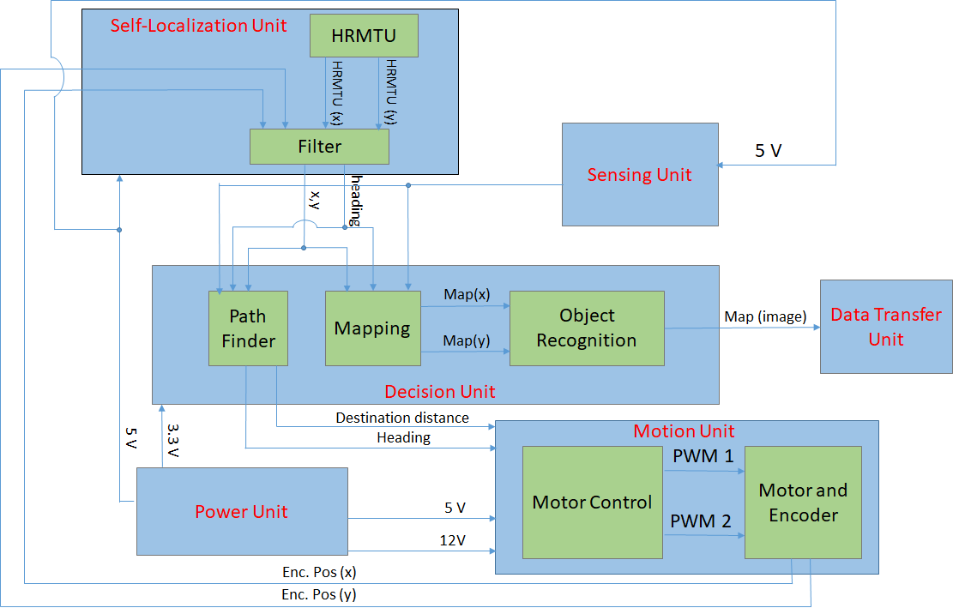

Figure 1 A detailed block diagram with signal definitions and voltage levels

The devices start with the start command. Then, it senses the environment and takes the data points (Objects and walls).  A mapping matrix is created. If the area of the map is not filled enough, the device creates a destination point and moves. Otherwise, the map is sent the object recognition algorithm. The map and results of the object recognition algorithm are transferred to the monitor for displaying the map to the user. The overall flow chart of the system can be found in Figure 2.

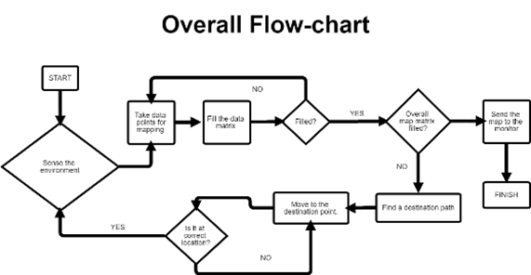

Figure 2 Overall flow chart of the system

**Self-Localization Unit**

The robot is not stationary. The position and heading angle changes with respect to its movement. Because of all, it is required to obtain a position and heading angle to create relate the robot’s measurements to an overall map. We solve this problem with High-Resolution Movement Tracking Sensor (or it is basically a part of a mouse). The HRMT sense changes in x and y at each 100msec. The data are processed by the microcontroller and the position and heading changes are created. Self-Position is at origin and heading is 90 degree at first starting. Then the changes in heading angle and position are added.

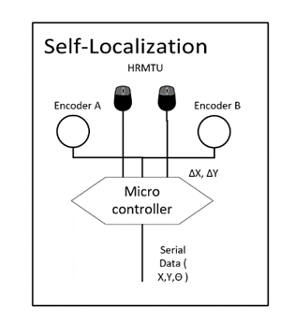

Figure 3 System level interactions of Self Localization Unit with signal interpretation

**Materials:**

* **HRMTU:** High-Resolution Movement Tracking Sensor sends a change in 2-dimension space at each 100 msec., 2 Trackball Mouse.
* **Encoder:**The motion of the motor is measured by the encoder to find the change in 2-dimension space.
* **Microcontroller: I**t governs timing and reading of the HRMTU data and Encoder data, Arduino Nano

**Inputs and Outputs:**

**Power Input:** 5 V for HRMTU, Encoders and microcontroller.

**Data Output:** Serial data of Self Position and heading angles of the devices for each 100 msec.

**Decision and Control Unit**

Decision and Control unit governs the other unit and processes the data. Mapping algorithm adjusts the measurement of sensing unit by the self-localization and creates the real data. Also, path finder controls the map and find the unseen points of the map. After the path finder makes shape recognition starts, the devices stop and the taking data finishes.  The Shape Recognition algorithm creates the shape, size, and center of the object and creates a map as images and sends those to the data transfer unit. Block diagram of the unit is illustrated in Figure 3.

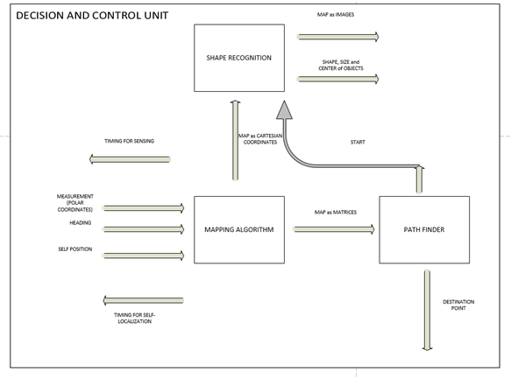

Figure 4 System level interactions of Decision and Control unit with its signal interpretation

**Materials:**

**Microprocessor:** For operating the algorithms, Raspberry Pi 3 B

**Inputs and Outputs**

**Power Inputs:** 5V with 1A capability

**Timing Outputs:**Adjusting the flow of operations

**Measurement Inputs:**

* Taking Objects and walls data from 4 distance sensors
* Taking self-localization information from High-Resolution Tracking Module (HRTM) and DC motors encoders

**Destination Outputs:** Sending PWM’s of motors for movement

**Mapping Outputs:** Sending final map data with different headers (shape, size, and center) to the data transfer unit

**Motion Unit**

The motion unit is required for the movement of the devices. The movement of devices are provided by a differential drive with two motors with encoders. The PWM data are created by the decision unit and these motors are driven with PWM by using motor drivers. The block diagram and signal definitions are in Figure 5.

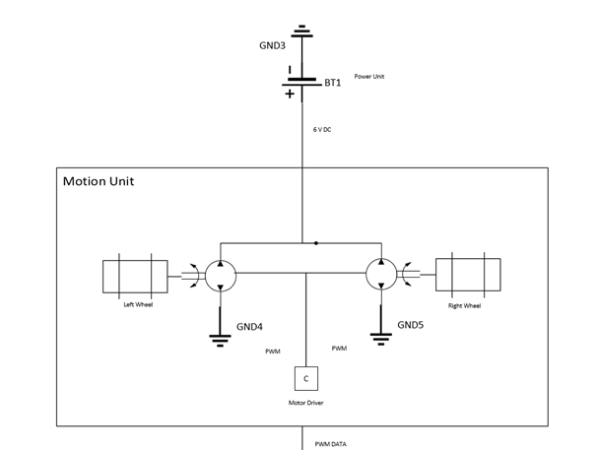

Figure 5 System level interactions of Motion Unit with its signal interpretation

**Materials:**

DC motors: 2 DC motor to move 2Dimension

Motor Drivers: It controls the speed of the motor by PWM

**Inputs and Outputs:**

**Power Input:** 6V - 0.6A

**PWM Input:**  PWM inputs to adjusting motor speed and movement to a destination point.

**Sensing Unit**

In this unit, we need to determine the objects that surround the device. To determine the positions and types of objects, we need to transfer the field into a binary understanding of the device. To accomplish this task, we need to understand whether there is an object or not.  Thus, we use the ‘distance sensor’ to detect the object.

Figure 6 shows the block diagram of the sensing unit. There are 4 distance sensors which placed on 90 degrees differences. The sensors communicate with microcontroller by using I2C Communication protocol. The sensors are used like LIDAR. Each sensor is rotated by a stepper motor. Thus, each measurement four sensors collect data in 360 degrees totally. The stepper motor is controlled by using a stepper driver.

Measurements occur while the device is stationary. It is sent by the decision unit. After the four sensors rotated 90 degree, the outcome data are stored to convert serial data to distance matrices in the shape of polar coordinates. Also, the data are controlled by the sensing unit to avoid false data. The data are stored with consecutive angles. The difference of radius of each consecutive angle is controlled if the difference is much more than average distance, these data will be erased.

**Materials:**

**4 Distance Sensor:** Communicate with I2C protocol with microcontroller. The measurement time is taken from Microcontroller.

**Step Motor:** Driven by a stepper motor, the position of measurements is logged.

**Microcontroller:** It provides communication with the Decision Unit. Also, it governs the timing and storing of data.

**Input and Outputs:**

**Power Input:**  6 V DC for step motor and stepper driver. 5V for sensor and microcontroller.

**Measurement Time Input:**Time of taking data is adjusted by decision unit while the device is stationary.

**Measurement Coordinates:** Measurement of the distance for 360 degrees are sent in the set of polar coordinates to decision and control unit after the measurement operation finished.

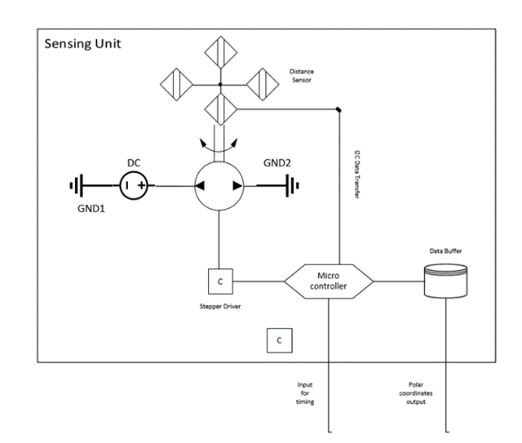

Figure 6 System level interactions of Sensing Unit with its signal interpretation

**Power Unit**

Power unit supplies all electrical components with DC voltages at the required level. Our power unit includes Li-Ion Cells with parallel and series to adjust the voltage and current ratings. Our electrical components operate at different type of DC level.  There are 3 DC levels. 3.3 V DC is used for the main microprocessor, 5V is used slave microcontrollers and sensors. 6V DC is used for Motor drive. In Figure 7, the power unit block diagram can be found.

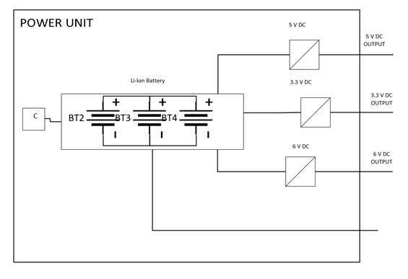

Figure 7 System level interactions of Power Unit with its signal interpretation

**Materials:**

* Li-Ion Battery: Supplying power
* Buck Converters: It controls the voltage level for a different subsystem.

**Inputs and Outputs**

**Outputs:** 3 different voltage level for subsystems.

**Data Transfer**

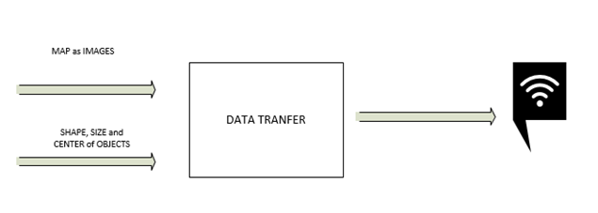

Figure 8 System level interactions of Data Transfer with its signal interpretation

This is the final step for the project. As shown in Figure 8, The unit takes the map and properties and sends the data wirelessly to show the output.

**Materials:**

* Wi-fi Module: Providing wireless communication

**Inputs and Outputs**

**Power Input:** 3.3 V for Wi-fi Module

**Image:** Final version of the overall map that contains shape, size, and center of objects

**Mechanical Drawings**

|  |  |
| --- | --- |
| a)  **https://lh4.googleusercontent.com/XT-meb_XLOcQEc717I_7q2pKA3-5iwEdSTei1X2KK4ibI_CkfkGq0T25Wo7KvZIm-XoC_X8T8gif1gXNkdMcsKyH_Fo3kWH3WbRSN4_ip_N4nIR18d--0rB6pCWUNN-4tMPojCld** | b)  **https://lh6.googleusercontent.com/xLX4ZnoNfV6BhJbgAUW2dvv8QuVG1kW0o5NBniY0VRbGN2jXQdSBTbDSGiV8vj2hUrO4xkUvsnTUurVMJTKDTAcyR63EyjiWS2If_2PUOkH1wZIf_k07YuggzHVFeNj1MKObLAnK** |

|  |  |
| --- | --- |
| c)  **https://lh4.googleusercontent.com/LitjvZniQAd-dSMq12pqSUSbpcj4E3iz5LHrPjbXBX09aPxV0srYKlxXt7WwJV6nwPHs9ysnL4We7CN7mk72HK43A2gM4zljpbMpd4yKv3hnIJf2hkpkSem6NzCJbNR-8pTm8xkR** | d)  **https://lh4.googleusercontent.com/FfS_Z46prbbIGV2e_b-BiSAYnnZGJBbUmpCJMlna3iK9bfKFdg5QNkZ0PzVx-4IPa6q8jWb63El2Vmr_qjzTsob83alF00wnLJsxwr4lepfK-4KwjKpPujh9VMGWU6On1inTiox1** |

e)

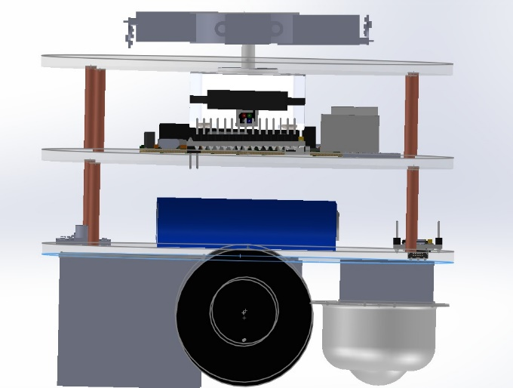

Figure 9 Mechanical Design of the overall project (a, b: isometric view, c: front view, d: top view, e: side view.)

**Requirements**

Motion Unit

* Motors should move with an average of 3.5 cm/sec velocity.
* Motion unit should get the destination data from the decision and control unit and should convert this data to PWM signals to move motors
* The encoders should give position data to the localization unit continuously.
* Motor should be able to bear on the weight.

Sensing Unit

* Sensors should be oriented to sense the environment with 360-degree range.
* The distances from 10 cm to 40cm should be sensed by the sensors to transfer the points to the decision unit because the optimum measurement range of the sensors that we used is from 10 cm to 40 cm.
* Sensing unit should generate 80 data per second.
* Sensors should give data continuously to operate in a synchronized way.

Decision and Control Unit

* The unit should combine data coming from the localization unit and sensing unit to obtain destination path and map data.
* Path planning part should give destination distance and heading to the motion unit.
* Mapping part should give x and y positions of data points coming from the sensing unit to generate a map.
* Object recognition part should collect data point position information and generate contours.
* Object recognition part should decide the types, centers of the objects.

Power Unit

* Power unit should have the ability to supply 4 A current at 5 volts at the time such that robot dissipates maximum power.

Localization Unit

* High-Resolution Tracking Module (HRTM) should give position data with less than 3% error.
* Kalman filter should model error and using the model, the filter should compensate the error.
* Localization unit should send the current position of the robot to the decision and control unit.

Data Transfer Unit

* Transferring Data properly from devices with wireless

**Design Modifications**

* The number of sensors in the sensing unit is increased to 4. With this modification, we are able to sense the environment in 360-degree range. With this ability, we can sense the environment at a larger range with one round turn.
* Instead of a servo motor, we used a step motor to rotate the sensing unit. Servo motor has some nonlinearities and because of the effect of nonlinearities, angle change in servo motor is not accurate. Step motor rotates with 1.8 degree per step and this can be decreased to 1/16 of 1.8 degree. This rotation is mostly linear and some distortions coming from the linearity of the rotating device is eliminated with this change.
* We created a two-dimensional interpolation algorithm in the decision unit. This improvement gives us more data points to process in the object recognition part. As the number of data is increased, distances between points which are sensed in the sensing unit are closer to each other in image and shape finder algorithm can operate more efficiently. An illustration of two cases is shown below.

**Compatibility Analysis of Subsystems**

**Motion Unit**

In this unit, both input and output exist since to move in the field, we need to give direction and destination distance to motor. To drive the motors we need a driver and we feed this driver with pwm signal from decision unit because we can arrange the speed of motors with pwm easily.

Also, to help localization, we need encoder data. Encoder gives mm data with respect to the device’s direction to localization unit.

To supply power, we feed this unit with two different voltage level 5V and 12V. 5V is for motor driver and encoder part. 12V is for DC motor part.

**Sensing Unit**

We can divide two subblock. One of them is collecting data from distance modules. Another module is rotating the sensing unit. Collecting data part gives distance between devices and objects in mm to decision and control unit.

To rotate sensing unit, we use stepper motor and to drive, we should command to it’s driver.

To supply power, we feed this unit 5V.

**Decision and Control Unit**

We can analyze this unit in three different part. First part is path finder. This unit takes XY coordinate and heading direction of the device from the localization unit. According to these data, it can specify the path. Second part is mapping. This unit takes XY coordinate and heading direction from localization unit and distance data from sensing unit. After interpreting the data, it gives the result to object recognition part. Third part is object recognition part. This unit takes XY coordinate matrix. it interprets the data and specifies the object’s types and centers. Then, it gives the data to transfer unit.

For this part, we use raspberry pi and it need 5V to operate.

**Power Unit**

Power unit should be able to supply different voltage level to the device. The unit can be split in two part. One of them is Li-Ion Battery a main power supplier at 7 V and 5 A rated.   Other one is buck-converters that converts the 7 V DC to 3 different voltage level.

**Localization Unit**

We can analyze this unit in three different part. First part is high resolution tracking module. This module gives XY coordinate to filter. Second part is encoder module. Encoder also gives position data with respect to heading direction. Third part is filter unit. In this part, we use Kalman filter. Then, filter unit gives XY coordinate and heading direction to decision unit.

**Data Transfer Unit**

This unit takes an image from decision unit and sends a mail map of the environment and properties of objects.

**Compliance with Requirements**

**Motion Unit**

To extract map clearly, the device needs to move. One requirement for selection of motor is that motor is able to bear on the weight. The device has one stepper motor, two microcontroller, one microprocessor and battery. The device will be more than 1.5 kg. Selected motor can bear on 10 kg, but it works inefficient according to datasheet and it operates maximum efficiency for 2 kg. The motor can go speed of 210 rpm. With respect to wheel radius, it can reach 43 cm/s. As requirement, we specify as 3.5 cm/s. If we take good results, we can speed up the device and we can finish mapping shorter time. Moreover, motor has encoder and we use encoder results for localization unit.

**Sensing Unit**

For scanning whole environment, we can use one distance sensor, but this takes a lot of time and we want to finish shorter time. For this purposes, we decided to use four distance sensors. Then, we rotate the unit 90 degrees for 360 degrees scanning. Also, one module can take almost 30 data per second and with four module, we can take at least 80 data per second and we achieve one of the requirements. Moreover, we need higher resolution to classify the objects and we decrease the step angle of stepper motor.

**Decision and Control Unit**

The most critical part in the project is decision and control unit since this unit takes position information, interprets it and with respect to that, occur destination part. Also, this unit occurs map that by taking different sensing data and classifies the objects. Shortly, this unit will make a lot of work. For this purposes, we cannot use a microcontroller, we need stronger controller and we decided to use raspberry pi. It can make parallel processing and it has stronger CPU. Also, thank to specific libraries, it can make faster calculation.

**Power Unit**

To work the device, we need a power source in the device. For this reason, we decided to use li-ion battery since they are cheaper and safer than li-ion battery. With respect to its number, we can arrange supply rating.

**Localization Unit**

We need correct location of the device to extract the map clearly. For this purposes, we need high resolution module and we decided to two mouse. Mouse can take almost 100 samples per second. We find this result by measuring time to take 100 samples. However, sometimes during the test, trackball can slip, and we take wrong result. To avoid this problem, we need another unit to measure the distance and we bought DC motor with encoder. Encoder gives result higher error, but we use Kalman filter to eliminate the error. Then, we take less than %3 error. Also, we took more error when mouse moves in arc path. We think that if the device follows straight path, we can decrease error rating.

**Data Transfer Unit**

After finishing scanning, we need to show extracted map and properties of object in the area to user. To achieve this, we use raspberry pi Wi-Fi module. We connect the device to the internet, and we send an email to user after finishing whole process.

**Test Procedures and Results**

**Sensing Unit**

**Sensor Employment**

At the conceptual design report, we proposed measurements for environment sensing is established via 2 distance measurement sensors. However, considering our design criteria which is short operation time, the speed of measurement is not enough. Each sensor takes 18-25 measurements per second as shown in Figure 10. In the Figure 11, the sensor measurements are transmitted via I2C communication protocol and its transmission base frequency is 100 kHz as shown in Figure 11.  For this case, the transmission window takes 40 milliseconds. The idle mode that the sensor takes the measurements and waits for the transmission window is at minimum 20 milliseconds. In the figure, it is chosen to be 50 milliseconds for stable operation. This limits the transmitted data size.

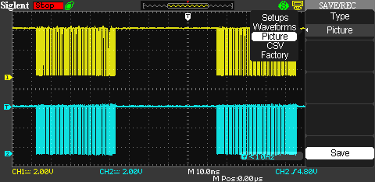

Figure *10* Data transmission of vl53l0x using I2C (CH1 and CH2 are clock and data signals respectively).

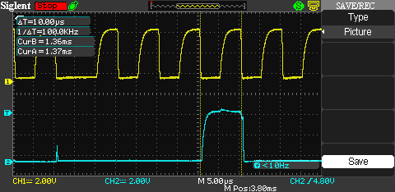

Figure 11 Data transmission of VLX53L0 using I2C (CH1 and CH2 are clock and data signals respectively.).

To acquire faster operation of ability of visualizing environment, we came up with using multiple sensors. In our critical design, we came up with using four vl53l0x arranged as in Figure 12. With the motion of the sensor in 90-degree radian, we obtain 360-degree visualization of the environment.

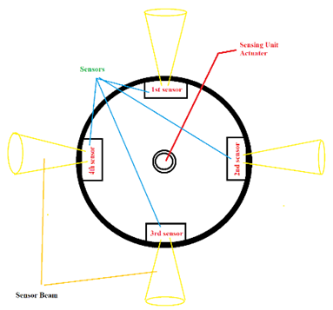

Figure 12 Sensor Orientation  
  
To be able to use four sensors, we needed to make changes in the library code of the sensor provided by its manufacturer STMicroelectronics. In first modification, we changed the trigger mechanism of the sensor and its timeout counter such that the measurement duration is shorten. As shown in Figure 13, the data transmission window is shortened to sequentially read the measurements from the sensors. As shown in the figure 13, the data transmission window takes 12.5 milliseconds with idle mode of 20 milliseconds when I2C clock rate is 100 kHz, the same as previous case.

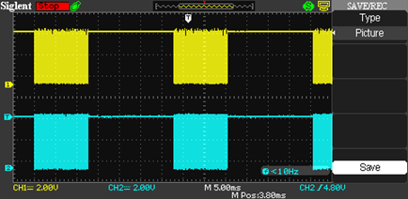

Figure 13 Data transmission of VLX53L0 using I2C (CH1 and CH2 are clock and data signals respectively.).

To acquire multiple measurements from different sensors at the same time, we fuse all the sensor measurements into single transmission window as it can be seen from the figure 14. With this result, we can obtain 80 measurements per seconds.

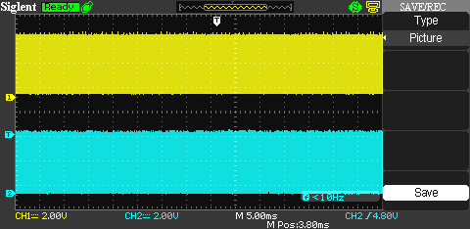

Figure 14 Data transmission of VLX53L0 using I2C (CH1 and CH2 are clock and data signals respectively.).

The timing diagram of the sensors is shown in Figure 15.

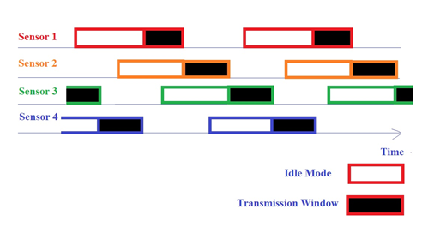

Figure 15 Timing diagram of the sensors

To examine the four distance sensors configuration, we established a setup with 12 walls and 3 objects in the Figure 16. We tried to take data for specified environment in the project description. We used 1 step to rotate the sensors and we rotate the sensors 90 degree clockwise. We took the result from three different points. We took self-localization data with hand measurement. Then, we merged the three different data points in the MATLAB, and we took result in the figure xxx.

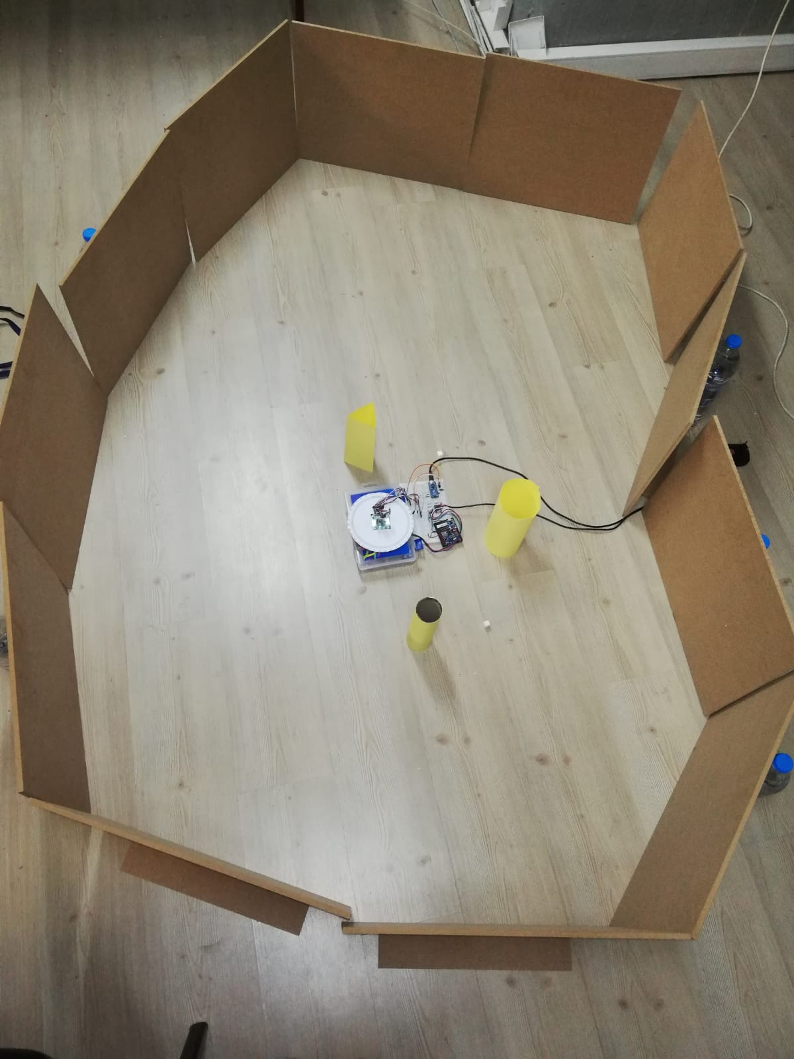

Figure 16 The test setup for four sensor configuration.

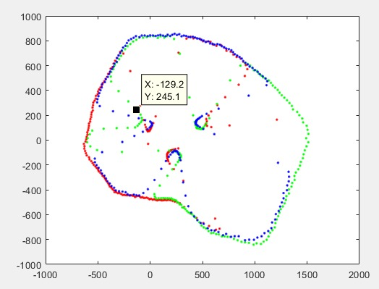

Figure 17 The resultant map of the setup.

**Test Results**

With this test setup, an improvement in the algorithm is required.  From the resultant map in the Figure 17, the measurements overlap. However, for each sensor measurement, the data consists of accumulated and fringing measurements. The fringing measurements prevents our mapping algorithm to detect and classify objects. This problem is to be solved via average discard filtering.

**Localization Unit**

**Test Setup**

We read the sensor data with Arduino Nano. The related calculations made at MATLAB and Arduino environments. We measure the ground truth using millimetric papers. The mouse test setup can be seen in Figure 18.

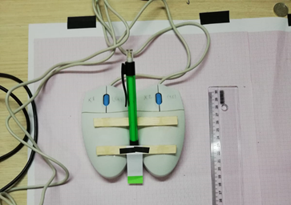

Figure 18 Mouse test setup

Test Setup

|  |  |
| --- | --- |
| **Test** | **Expectation** |
| Straight Line 1 at a small distance | Is the unit measure the distance with MEA less than %1? |
| Straight Line 2 at large distance | Is unit measure the distance with MEA less than %1  Is the effect of cumulating the error seen? |
| 2 Direction movement at an acute angle  () | Is the unit measure the heading angle with MEA less than 1 ? |
| Arc (Quarter circle) | Is the unit measure the final destination with MEA less than %1?  Is the unit measure the heading angle with MEA less than 1 ? |

*Table 1: Test Procedure*

**Test Results**

|  |  |
| --- | --- |
| https://lh3.googleusercontent.com/sXtcAv6aad__crE4-sTUGV1NnZZ0_3kF20LmzS9JOVk1wNjgVbw5O_x-eei_oaS9qZp7tWfB8cxTJxFYzle_7oW-DQh9zNSuU4l4sPe3fq-qmXWaqy4Rs0KlU-a-dntI8ZtGazwH  Figure 19 Test 2 results | https://lh3.googleusercontent.com/Bzvb2K_VbT1se9SKpKNuMS5BM8afbeEaxpop7klfiry5ZauaUW06sJA3AvDOG7QkH2NAKvEgehRHVxsCU1CI7deqzjDHPSObPrbvS8HQKC0h8n32J07Y2gPHzlSX3hi0BDCYNBRQ  Figure 20 Test 3 results |

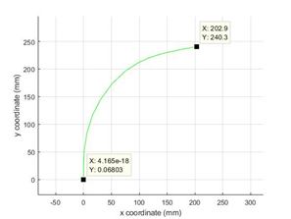

Figure 21 Test 4 results

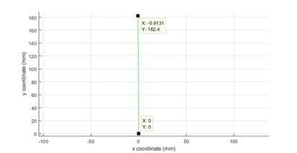

Figure 22 Test 1 results

**Errors**

Table 2 Errors

|  |  |  |  |
| --- | --- | --- | --- |
| **Test No** | **Ground Truth** | **Measurement** | **Error PMAE** |
| 1 | x = 182 mm | x = 182.4 mm | 0.2 % |
| 2 | x = 350 mm | x = 349.6 mm | 0.11 % |
| 3 | 𝜃 = 65.5° | 𝜃 = 65.12° | 0.58 % |
| 4 | x = 210 mm  y = 210 mm | x = 202.9 mm  y = 240.3 mm | 7.9% |

**Conclusion of the test**

From these test result we conclude that;

o   Two mouse method high accuracy when the motion of basic. (Straight line, L shapes etc.)

o   When the roadmap getting complex, the error due to measure is grow cumulatively. Therefore, roadmap algorithm should be robust or cumulative errors should be deleted via filters, i.e. Kalman filter.

**Resource Management**

**Cost Analysis**

The detailed cost analysis table of the robot is at Table 3.

Table 3 Cost Analysis

|  |  |  |  |
| --- | --- | --- | --- |
| Product | Price/Product ($) | Number of Pieces | Total Cost ($) |
| Raspberry Pi 3 B | 41 | 1 | 41 |
| Arduino Nano | 2.32 | 2 | 4.64 |
| Trackball Mouse | 1.9 | 2 | 3.8 |
| VL53L0X Sensor | 2.5 | 4 | 10 |
| L298N | 0.44 | 1 | 0.44 |
| Step Motor | 5.99 | 1 | 5.99 |
| Step Motor Driver | 1.1 | 1 | 1.1 |
| Motor Set | 23 | 1 | 23 |
| Battery cells | 3.7 | 6 | 22.2 |
| Plexi Chassis material set | 7 | 1 | 7 |
| Bolt & Screw Set | 5 | 1 | 5 |
| Total |  | 21 | 130.4 |

**Power Analysis**

In this project, the power consumption varies as the robot follows its flow chart.

Depending on which subsystem is active and receiving command the power consumption is given in Table 4.

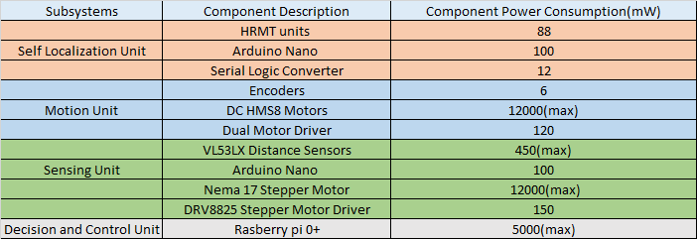

Table 4 the measured power consumption of the subsystems for their designed operation.

**Power Distribution Diagram**

The power distribution is shown in Figure 5. Using the power distribution diagram can be specified with the information given in the measured power consumption table.

Table 5 Power Distribution Table

|  |  |  |  |  |
| --- | --- | --- | --- | --- |
|  |  | Rated Volatge(V) | Rated Current(A) | Power(W) |
| Line 1 | Desicion and Control Unit | 5 | 1 | 5 |
| Line 2 | Motion Unit | 12 | 1,20E+00 | 14 |
| Line 3 | Sensing Unit | 5 | 0,11 | 0,55 |
| Line 4 | Self Localization Unit | 5 | 0,5 | 0,25 |
| Line 5 | Sensing Unit(Stepper) | 12 | 1 | 12 |

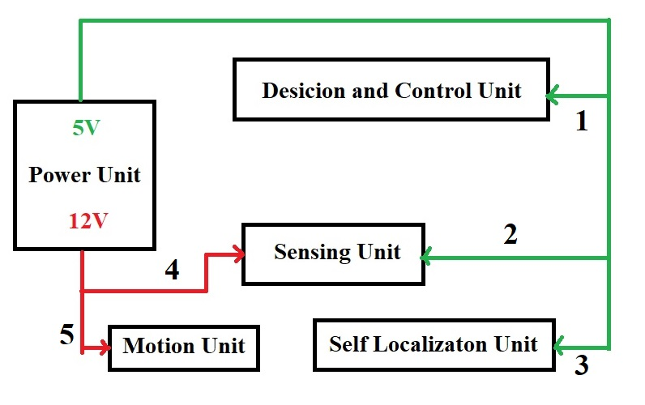

Figure 23 The power distribution of the overall system

**Project Schedule**

Our Gannt chart is at the Appendix with A3 size.

**Conclusion**

Our solution idea starts with data collection from the environment. From the first collection, the robot finds the nearest object according to its location and constructs a path. After completion of the path, the robot takes measurements at different points from the object and labels it as 'seen'. Then it starts searching for the newest 'unseen' object. Once the robot has tagged all objects and identified their types and locations, the robot transmits the map to the monitor over a communication channel.

In the first part of this report, we investigated detailed system analysis and subsystem level solutions. Our subsystem requirements were determined, and subsystem level solutions was created. There were some solution approaches at conceptual design report, we chose one of them solution with respect to our requirements. Also, we had some modification at some solutions. In addition, the subsystem level communication with each other are created and control and power signals are determined. Besides, the mechanical design and power distribution were created. The last part of the report consists of a detailed planned work, the work sharing of the team as well as the Gantt chart to present the project timeline. Test procedures, measurement of success, cost analysis and feasibility are also explained.

**Disclaimer**

Design specified in the report complies with the standards of the selected project.

Ali Aydın Anıl Aydın       Enes Ayaz

Nail Tosun Selman Dinç

**Appendix**